**Experiment No.: 3**

**Aim**

Familiarisation of Linux commands

**CO2**

Perform System Administration Task

**Procedure**

1. **Pwd** :-

The pwd command is used to display the location of the current working directory.

**$pwd**

**Output Screenshot**



1. **ls :-**

The ls command is used to display a list of contents of a directory.

**$ls**

**Output Screenshot**



1. **ls -R**:-

This command is used to list the contents of subdirectory.

**$ls -R**

**Output Screenshot**

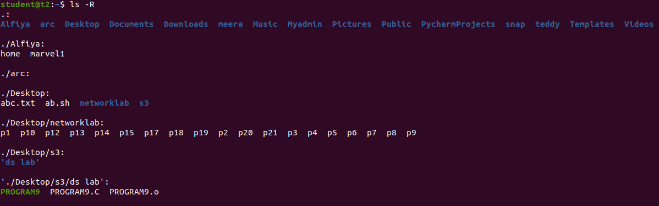

1. **ls -l:-**

The **"ls -l"** option displays the contents of the current directory in a long listing format, one per line. The line begin with the file or directory permission, owner and group name, file size, created/modified date and time, file/folder name as some of the attributes.

**$ls -l**

**Output Screenshot**

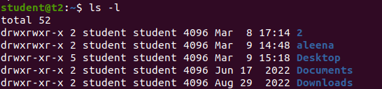

1. **ls -al**

This command is used to list the detailed information along with hidden commands.

**$ls -al**

**Output Screenshot**

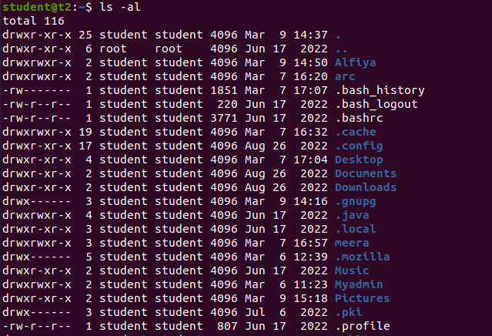

1. **ls -a**:-

This command shows the hidden files and directories in the current directory.

**$ls -a**

**Output Screenshot**



1. **ls -t** :-

This command list the files sorted in the order of the last file modified.

**$ls -t**

**Output Screenshot**



1. **ls -r** :-

The option **"ls -r"** lists all files and directories in reverse order. The files and directories are all arranged in reverse alphabetical order.

**$ls -r**

**Output Screenshot**



1. **mkdir**

The mkdir command is used to create a new directory under any directory.

**$mkdir filename**

**Output Screenshot**



1. **cd**

Linux cd command is used to change the current working .The "cd" stands for 'change directory.

**$cd filename**

**Output Screenshot**



1. **cd -- /cd ..**

This command is used to move to the parent directory of current directory, or the directory one level up from the current directory. “..” represents parent directory.

**$cd ..**

**Output Screenshot**



1. **History**

History command is used to view the previously executed command.

**$history**

**Output Screenshot**

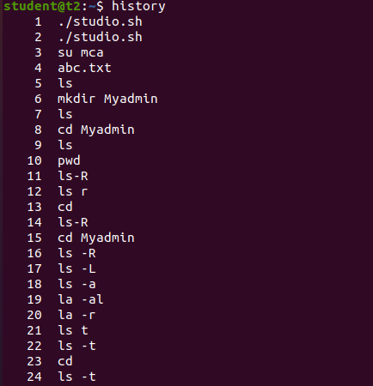

1. **man**

**man**  command in Linux is used to display the user manual of any command that we can run on the terminal.

**$man [command name]**

**Output Screenshot**



1. **cat command**

It reads data from the file and gives their content as output. It helps us to create, view, concatenate files.

**$cat > filename**

**Output Screenshot**

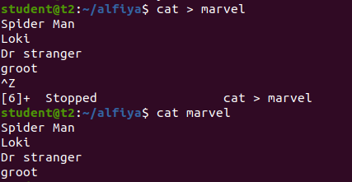

(a)**cat >>**

This command is used to append the contents of the file.

**$cat >> filename**

**Output Screenshot**

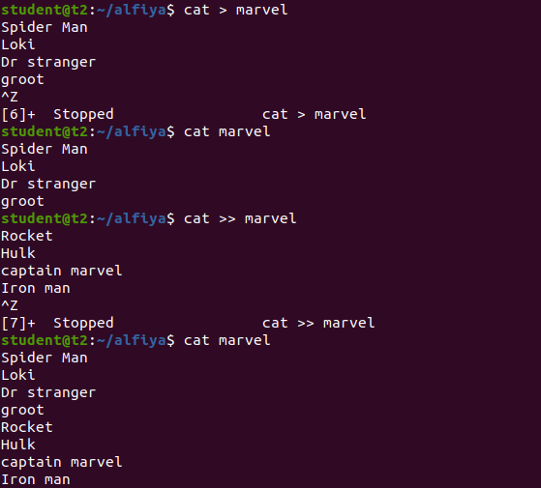

1. **cat -n**

This command is used to view contents of a file preceding with line numbers.

**$cat -n [filename]**

**Output Screenshot**

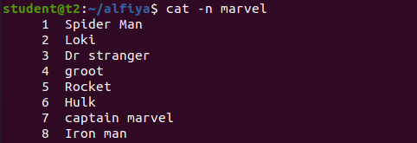

1. **cat -b**

This command removes the numbers from the empty line.

**$cat -n [filename]**

**Output Screenshot**

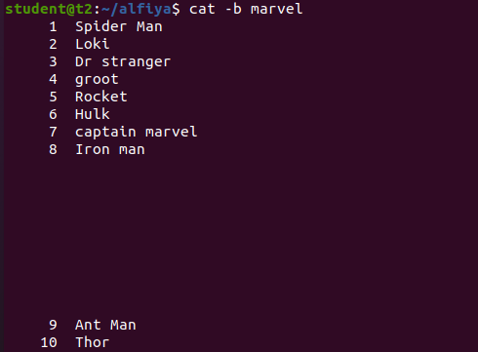

**Result**

The program was executed and the result was successfully obtained. Thus CO2 was obtained.